**LIST OF EXPERIMENTS(TM)**

COURSE CODE : CSA1381

COURSE NAME : THEORY OF COMPUTATION

NAME:k.Siva Naga Manoj Kumar

REG NUM: 192111630

**EXPERIMENT NUMBER 15:**

Design TM using simulator to accept the input string anbn

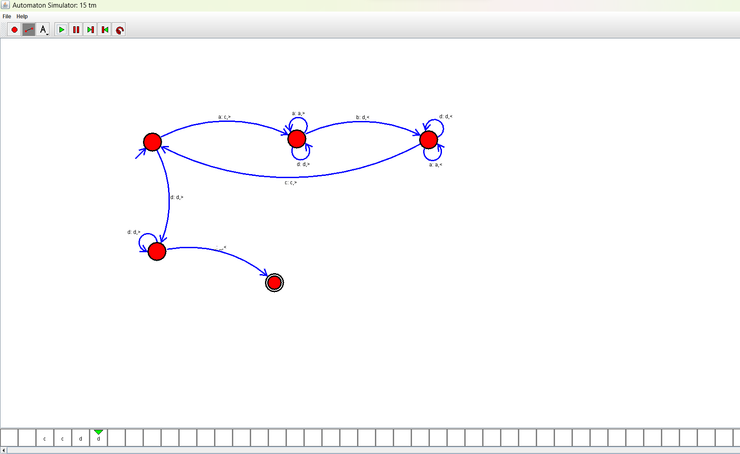

**EXPERIMENT NUMBER 16:**

Design TM using simulator to accept the input string anb2n

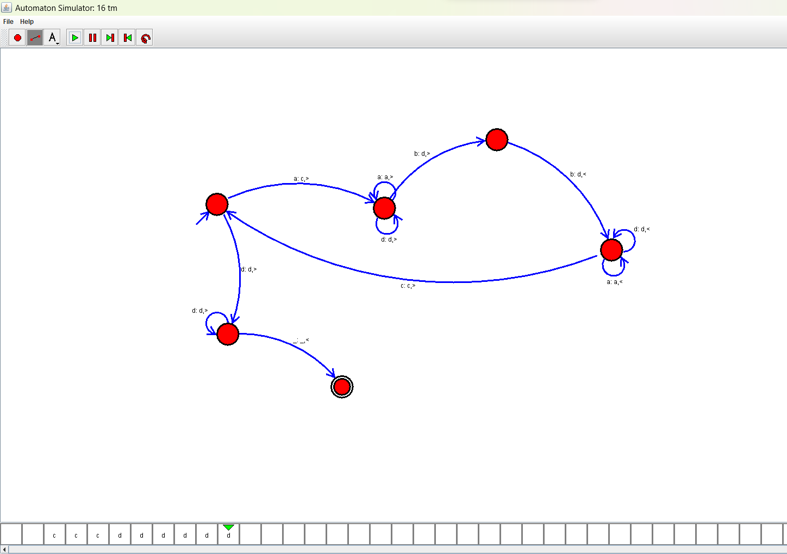

**EXPERIMENT NUMBER 17:**

Design TM using simulator to accept the input string Palindrome ababa

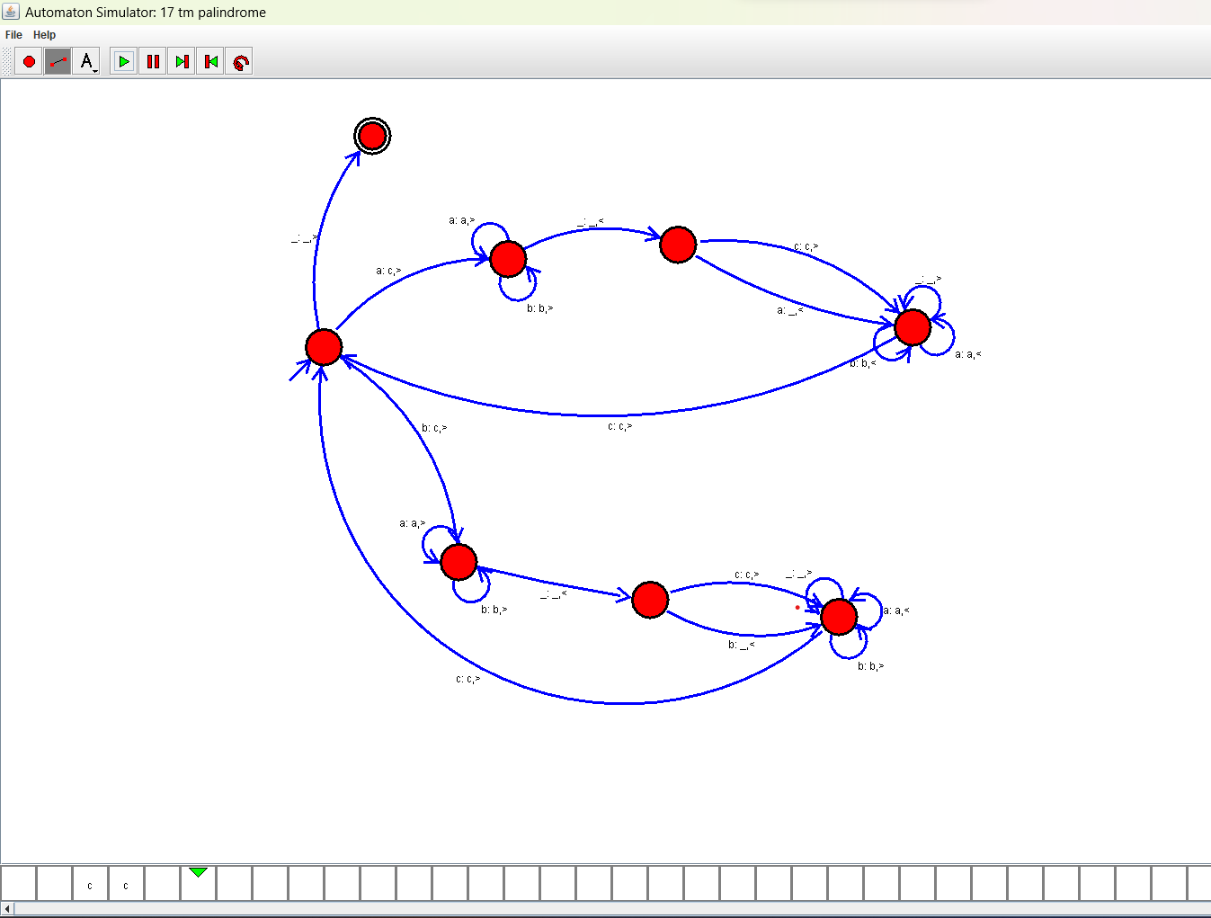

**EXPERIMENT NUMBER 19:**

Design TM using simulator to perform addition of ‘aa’ and ‘aaa’

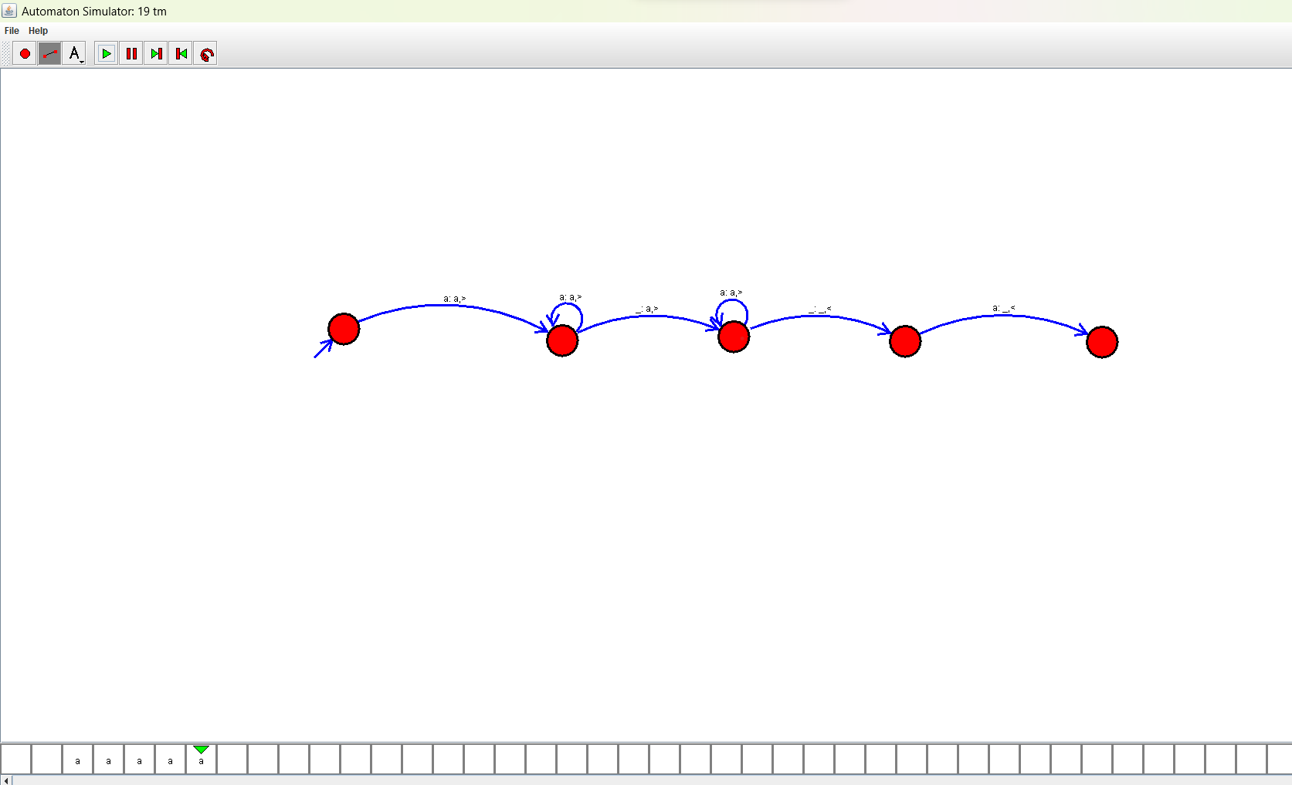

**EXPERIMENT NUMBER 20:**

Design TM using simulator to perform subtraction of aaa-aa

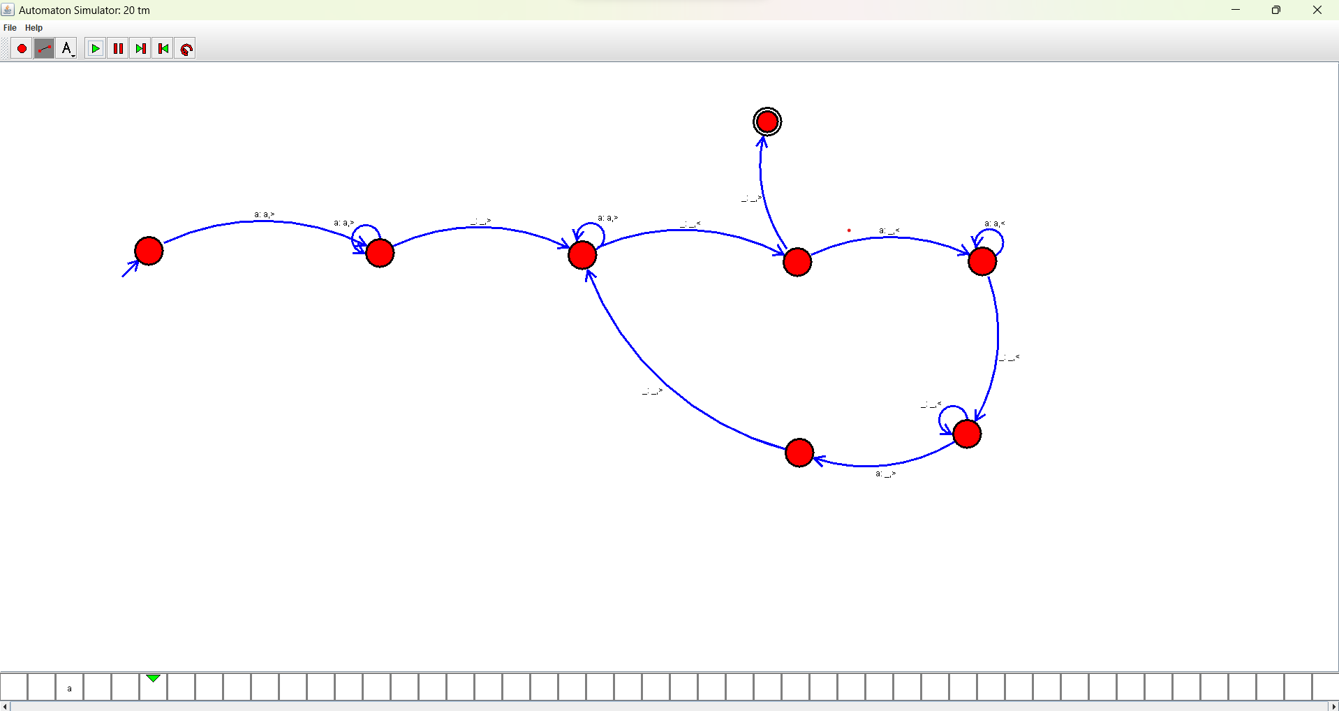

**EXPERIMENT NUMBER 26:**

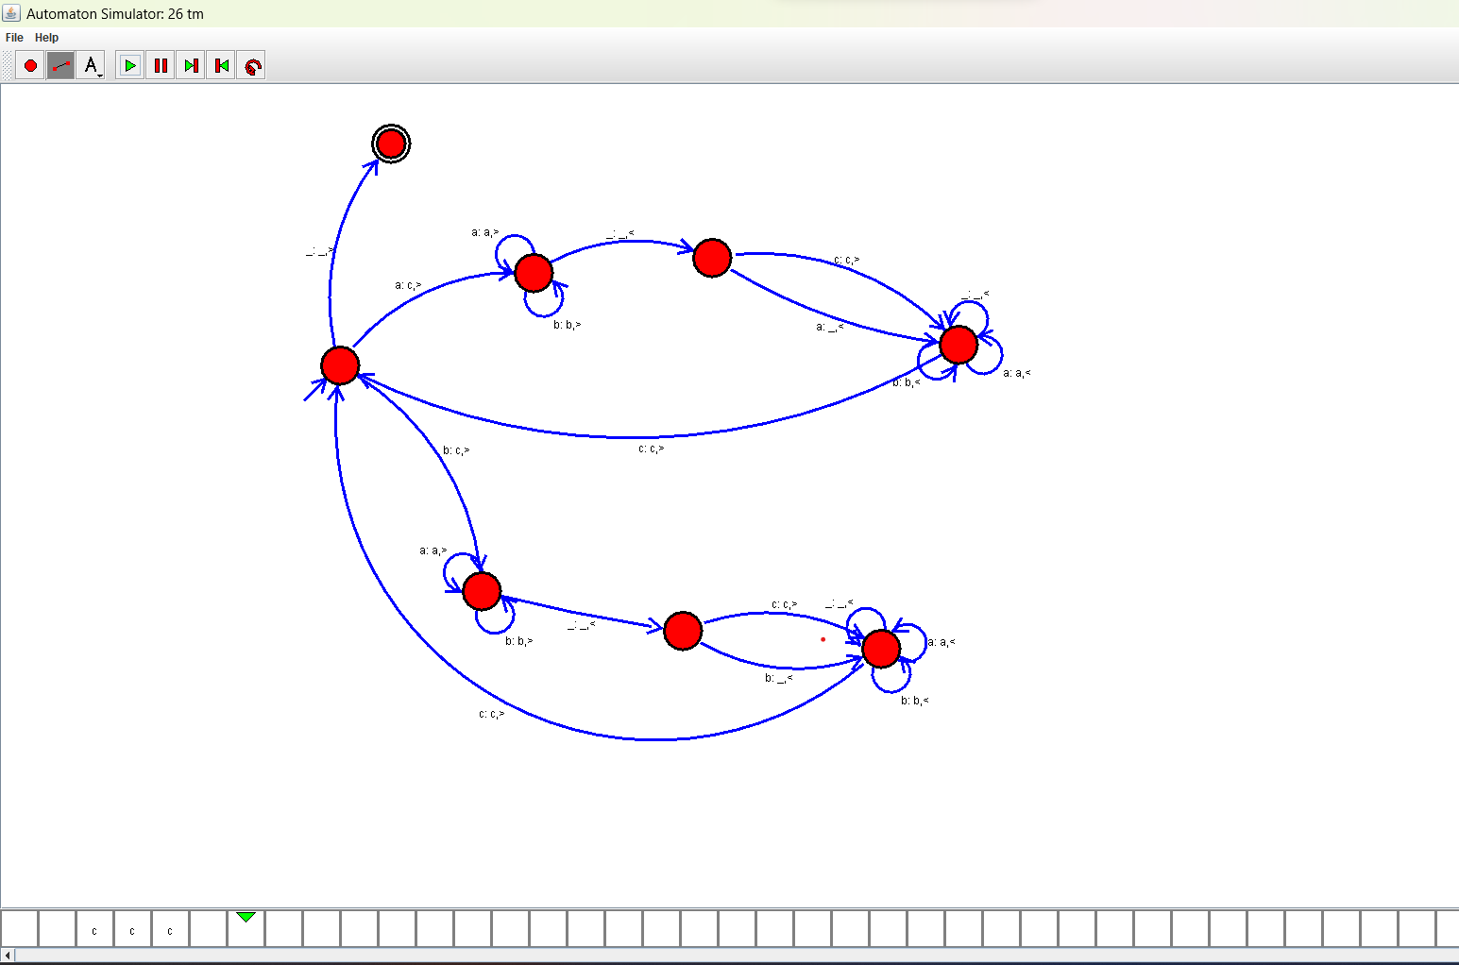

Design TM using simulator to accept the input string Palindrome bbabb